
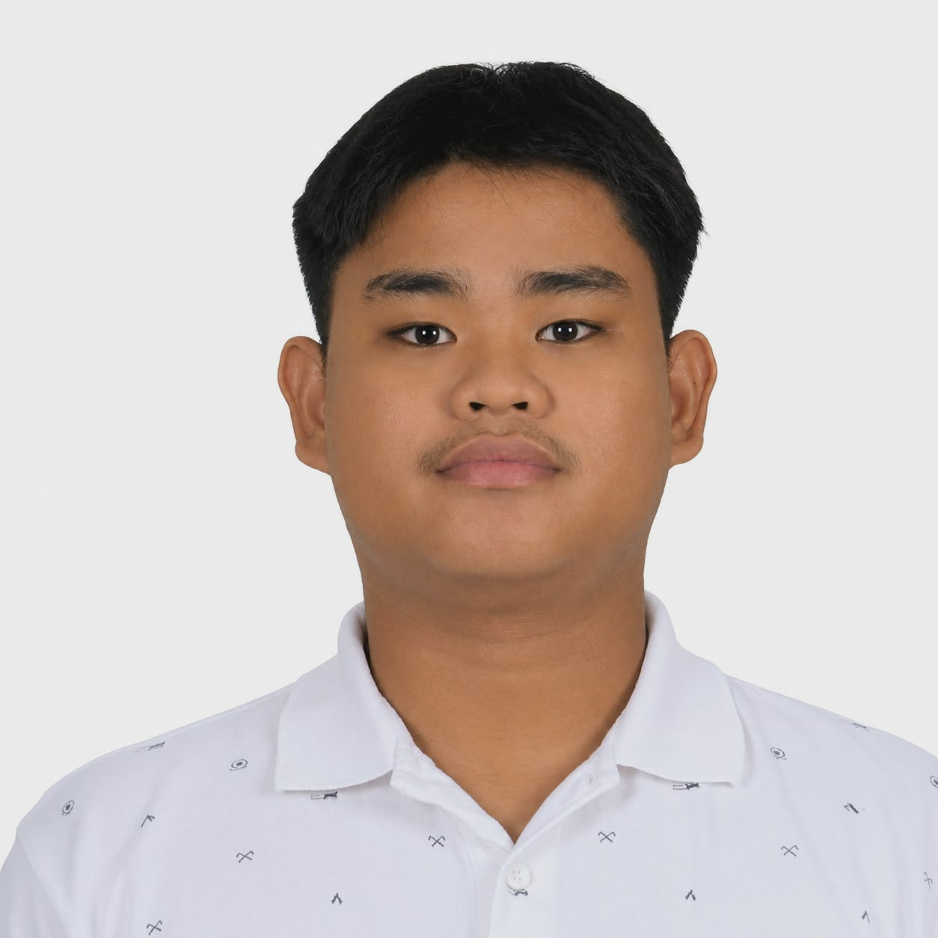
Vence Rey Haum
Bachelor of Science in Information Technology – 1st year
Baybay-1 Poblacion Bislig City | vencereyhaum@gmail.com | 09519693197 | haum.rey

Professional Summary
I am an Information Technology student who enjoys learning about programming, responsible, and always eager to improve my skills.
Career Goals
To become a successful IT professional and develop systems that help people and businesses.
Education
• Elementary School: Bislig Central Elementary School
• High School: Bislig City National High School
• Senior High School: Bislig City National High School
• College (Current): De La Salle John Bosco College
Skills
Technical Skills: Basic Programming
Programming Languages: Java
Software Applications: Canva
Soft Skills: Communication, Teamwork, Time Management
Featured Project
Student Information System
A web-based system for managing student records efficiently.
Language: Java
Status: Under Construction
Achievements & Certifications
• Certificates Earned: Certificate of Participation
• Academic Awards: None
• Seminars and Workshops: Not specified
• Work Experience: None
Personal Motto
Success comes from hard work, perseverance, and faith in God.

